UNDERSTANDING DOCUMENT
LSS PORTAL
Admin access for report visibility:
- Admin login is not having a report visibility. For this, we need to add consolidated tracker in the report section.
- We need to add consolidated tracker view (Report) under admin login same as currently visible to PM and QPE Lead.
- All the fields like search filters, fields in the report would be same as that of that visible to PM and QPE under consolidated tracker. (Please refer screenshot below)
- Admin will be able to view all records of consolidated tracker irrespective of a single PM or QPE Lead view.
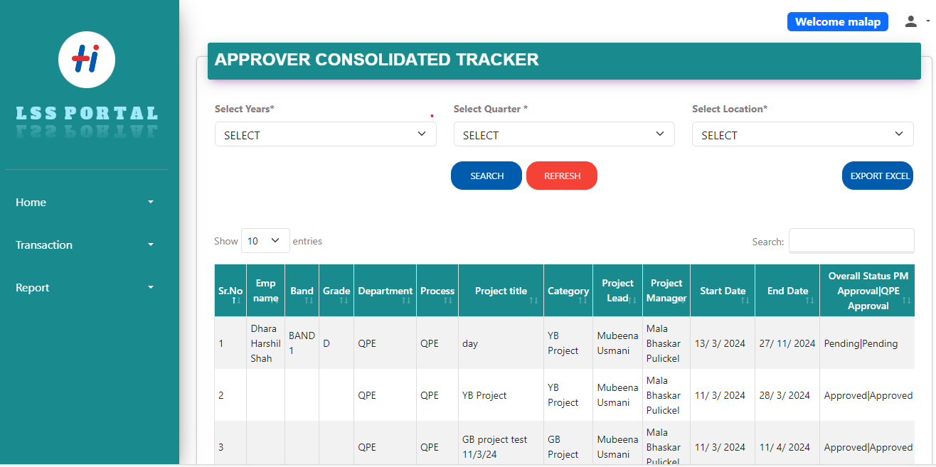
Please find the below screen for your reference.

Visibility of deck while approving and user admin access
- Alongside entering project benefit details section we have to allow the project leads to upload the complete deck or one slider. It should be mandatory before it goes for approval to PM and QPE Lead. (One slider has to be made mandatory)
Please refer the below screenshot.
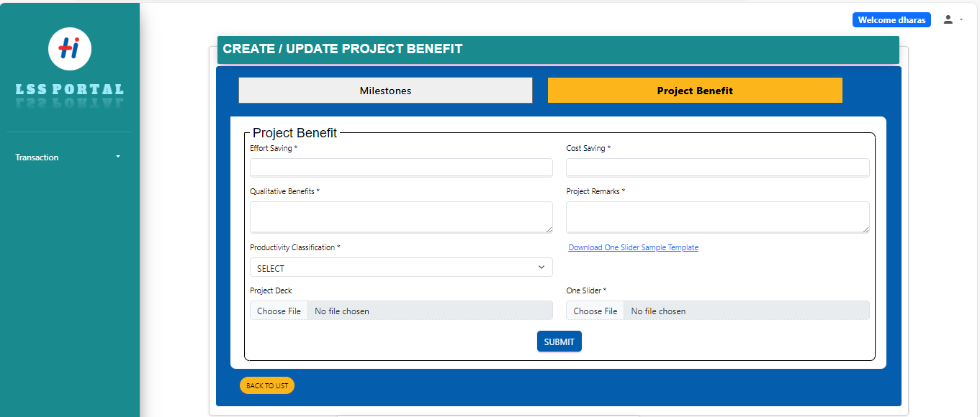
One slider and project deck has to be uploaded alongside entering project benefit details only after uploading these details can be sent for approval.
- When the PM and QPE approve the project benefit detail there should be a provision given to them to view project deck/one slider uploaded by project lead.
Please refer below screen.
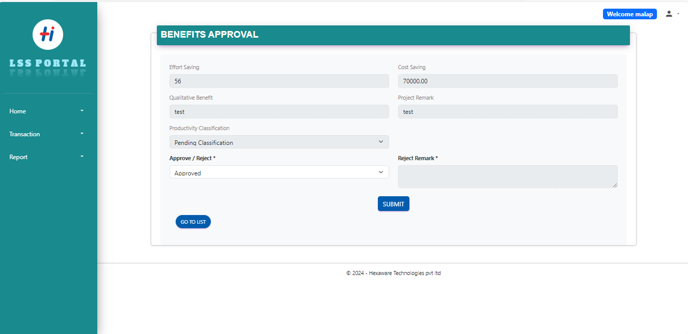
Provide a provision for PM and QPE Lead to view project deck/ one slider before the approval.

- Also when the PM and QPE lead have approved project benefit details they should be able to view project deck and one slider under reports.
Please refer below screen
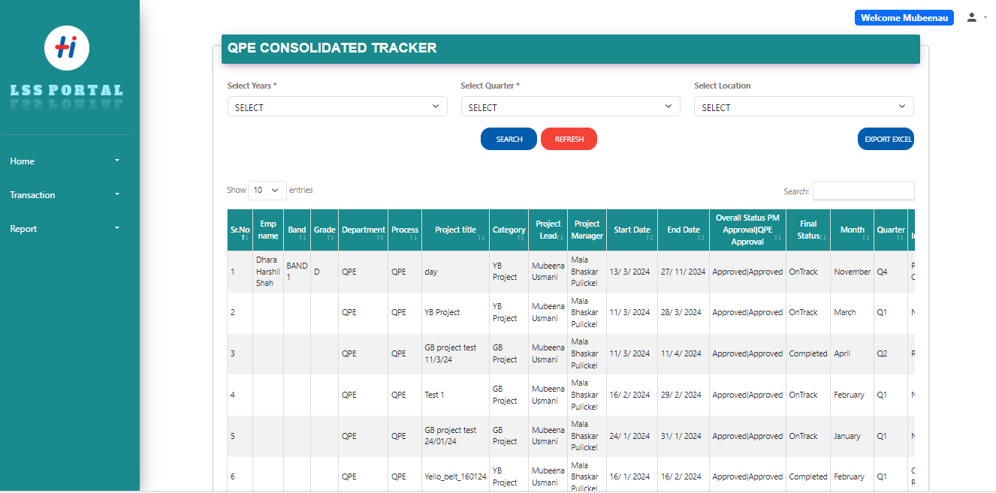
- Admin will also have view of all decks/one sliders under report (Consolidated Tracker).
Need to give visibility of project deck/one slider under report.
Project Milestone and date change option
- Currently the project lead can initiate the YB project with 2 months window and GB with 3 months but that need to be changed to 3 months for YB & 6 months for GB project respectively.
- There has to be separate screen develop where in the project lead can ask for an extension if he/she fails to complete YB project in 3 months or GB projects in 6 months. In that screen there should be a remark column which is to be filled by project lead stating the reasons for extension.
- Please refer below screens(Note : wireframes are subject to change as per development)
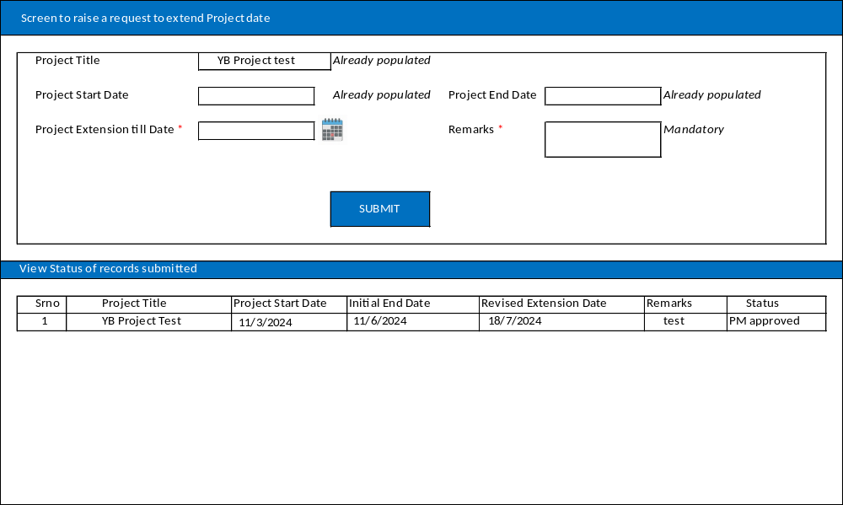
Note: Need to keep a validation where project lead can only extend further for 2 months after the 3 months and 6 months maximum date criteria has reached for YB and GB projects.
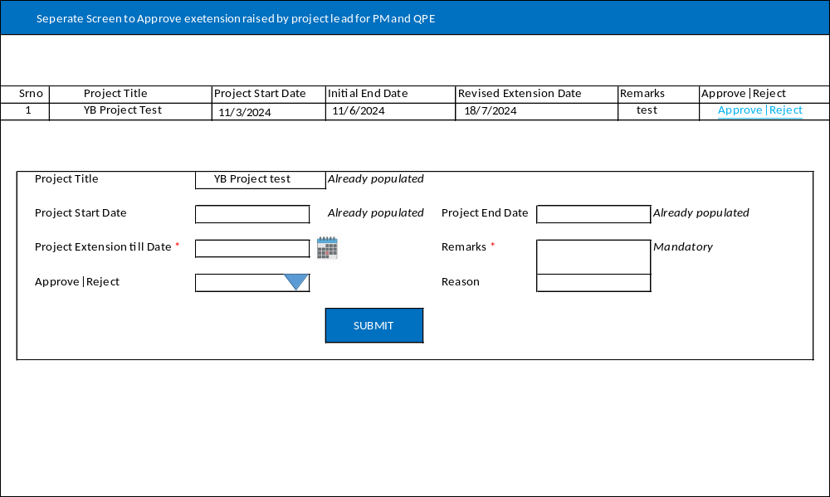
- After request is raised it should go to PM and QPE Lead for approval.
- If users are requesting for extension then they can extend it further up to 2 months. (Refer above note)
Sustenance workflow
- After the final deck is submitted and all approvals are done, then the system should navigate the project lead to Sustenance page without which the project will not be marked as completed.
- In Sustenance page, there will be two windows i.e. Pre Performance and Post Performance and expectation dropdown. They have to fill these details.
Pre-Performance
UCL Average P LCL
Post-Performance
UCL Average P LCL

Note:
- UCL is upper control limit
- Average P is average performance.
- LCL is lower control limit.
- We need to create drop down menu for expectation in which we have to list value
- Whether higher the better
- Lower the better
- Within range is better.
- The project lead needs to enter pre-performance, post-performance and expectation criteria (The expectation criteria would be given by QPE team and defined in the system).
- After entering the above details every month the project lead will again come to the screen and check whether the project is meeting the metric or not based on the post-performance value and criteria defined.
- The project lead has to do this entire activity for the next 6 months.
- Following fields have to displayed when the project lead selects the metric for specific month
M1 = if met / if not met
- CASE: If M1 is met then the project is meeting the sustenance data point.
- CASE: If M1 is selected as not met then PL need to enter RCA, CPA and timeline. RCA is root cause analysis, CPA is Collective and preventive analysis and timeline is the time by which sustenance will be achieved.
- They will also get option of selection of Marginal miss if there is margin difference and remarks need to entered by project lead which will further go for approval to PM and QPE Lead. In this scenario, RCA and CPA is not required. If the marginal difference is not approved by PM and QPE, then the PL will have to enter RCA and CPA.(Will require a separate screen for this)
- Need to also add project ID against these fields. Every time the new project is started a new sustenance workflow will start.
- If the PL is not filling the metric point then the mail should shoot out to project lead stating that you are filling the sustenance data points.

